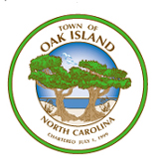

As of July, 2020 there are no major street projects taking place. This page will be updated accordingly.

