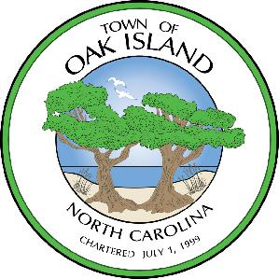

AGENDA

OAK ISLAND BUSINESS ADVISORY BOARD
TUESDAY, MARCH 26, 2024 – 9:00 AM
POLICE TRAINING ROOM - OAK ISLAND TOWN HALL

CALL TO ORDER

Alma Rittenberry, Ronnie Russell, and Zach Fisher were absent.

- APPROVAL OF AGENDA

- APPROVAL OF MINUTES III. PRESENTATIONS

III.1 Presentation from Alec Allred, Old North State League

Mr. Allred attended and spoke about the presentation he gave to the Town Council in December. He is an Oak Island resident and interested in starting a new summer wooden bat league team in the Town. The Old North State League started in North Carolina in 2019 and now has over 700 players. Their typical model is to do a land lease with a municipality, but they spend the money to upgrade the facility. The season is from about May 15 to August 15 with a 40-game schedule and 25 home games. The league runs on a host family model where players would stay with host families during their time on the team. Mr. Allred’s current proposal is to upfit the back field at Bill Smith Park. Several board members asked about the possibility of having it at the Middleton Park field. Mr. Allred explained that there are pros and cons to both locations.

IV. PUBLIC COMMENT

- OLD BUSINESS

V.1 Discussion of Off-Premise signage

Ms Willis shared an update of the off-premise signage ordinance that the Planning Board is considering. Members were not completely against regulating off-premise signage in regards to height and brightness. There was concern expressed for a total ban because some businesses have more hardship in what’s currently allowed in the sign ordinance. Specifically business in the South Harbour area who are removed from any main thoroughfares.

Hugh made a motion to send chair Joe Yeager as the Business Advisory Board representative on this topic to the Planning Board, Lisa seconded the motion. Vote was unanimously approved.

V.2 Business Retention and Expansion Program

Review of the BR&E meeting with the Grape and Ale. Joe said he found it very helpful and a good way to seek more help on things his business needs. He used social media as an example and other members agreed that is a common need for small business owners. Mr. Guhse spoke about his experience using the Small Business Center who referred him to a consultant.

V.3 Opening a New Business improvements

Ms Willis shared an update on the Welcome Packet materials that the board requested. New material suggested was a sheet that has all the major events in the town listed.

VI. NEW BUSINESS

No new business.

VII. STAFF REPORTS

No staff reports.

VIII. BOARD MEMBER REPORTS

No board member reports.

IX. ADJOURN

Dixon made a motion to adjourn the meeting and it was seconded by Hugh. Vote was unanimously approved.

